**LAB ASSIGNMENT-1**

**INTERNET AND WEB PROGRAMMING**

**1. Design a website to demonstrate the knowledge of students in HTML tags, forms,**

**table, list and HTML frames.**

**i. Create a user registration webpage using HTML Form elements (Input types) for**

**a hackathon event registration. The webpage must contain the following input**

**types to get the details of the students**

**ii. # Input Types:- Text fields, Textarea, checkbox, radio button, submit button,**

**reset button, drop down box, images (if required).**

**iii. # Apply styles, Formatting tags of HTML for good design.**

**iv. # Embed audio or video.**

**v. # Perform form validations with HTML 5 elements**.

**SCREENSHOT OF THE EDITOR (CODE AT THE BOTTOM OF THE FILE):**

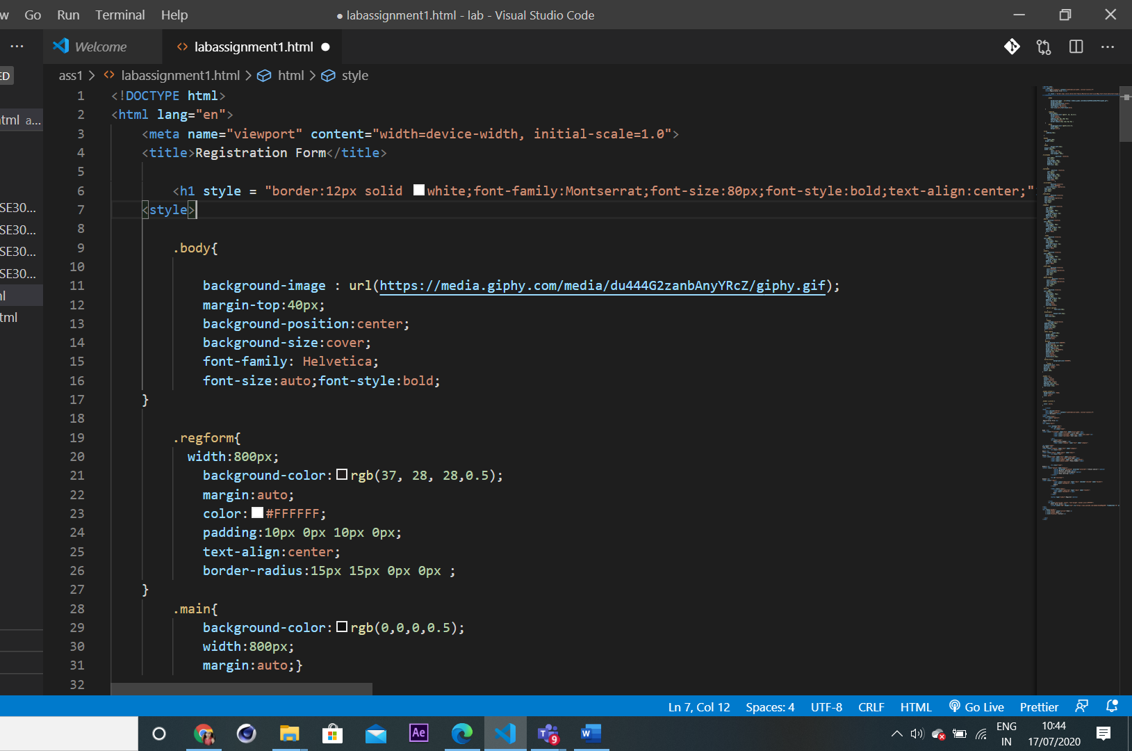

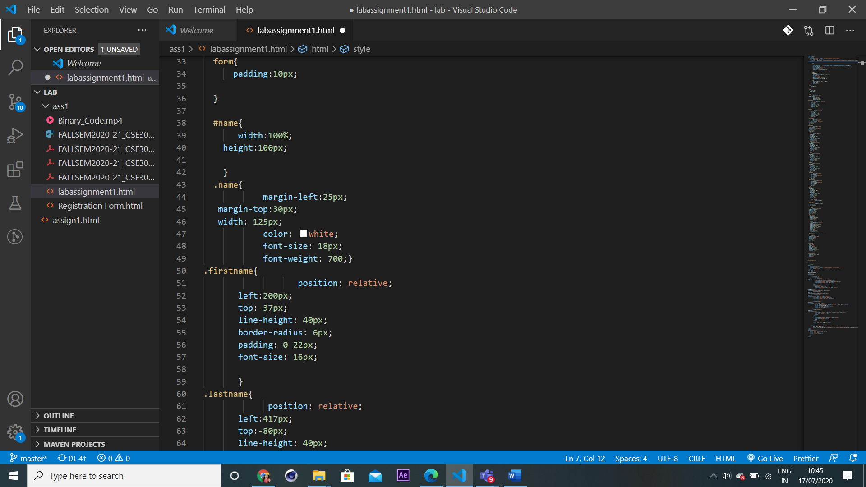

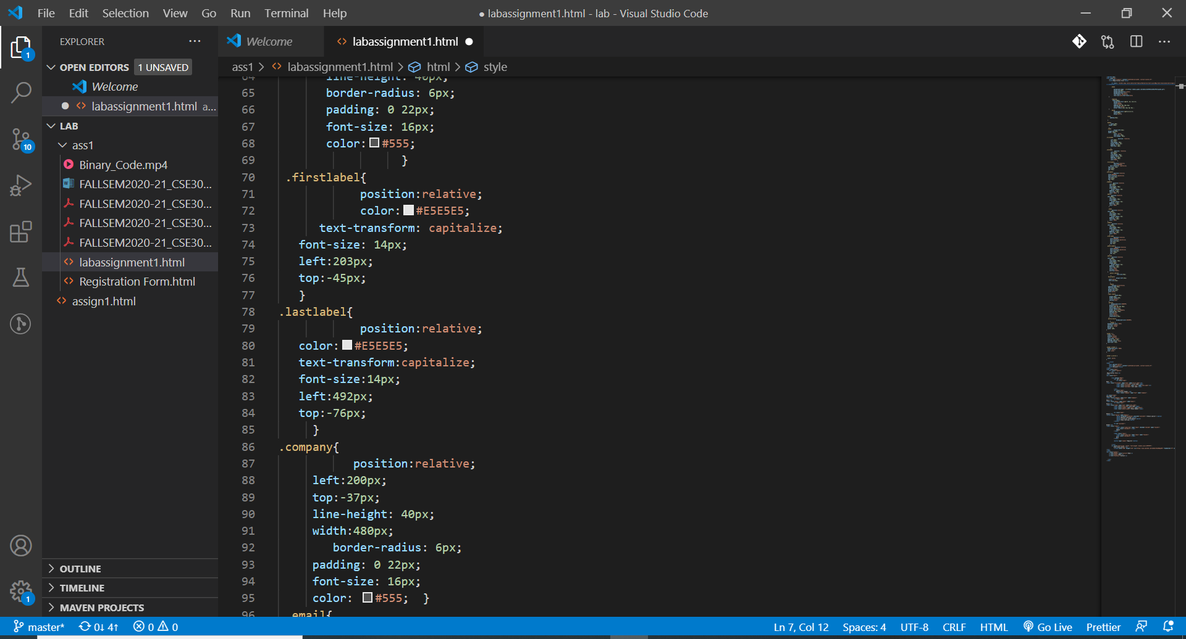

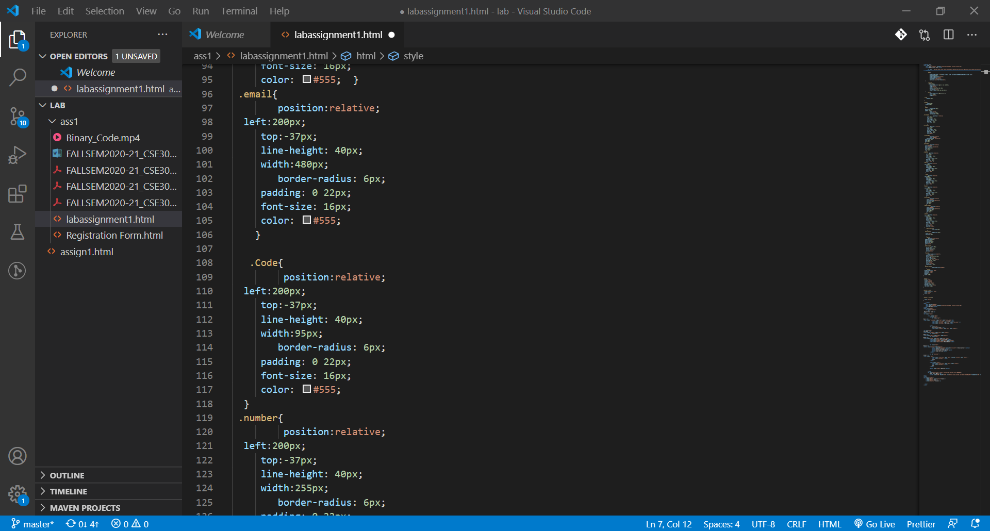

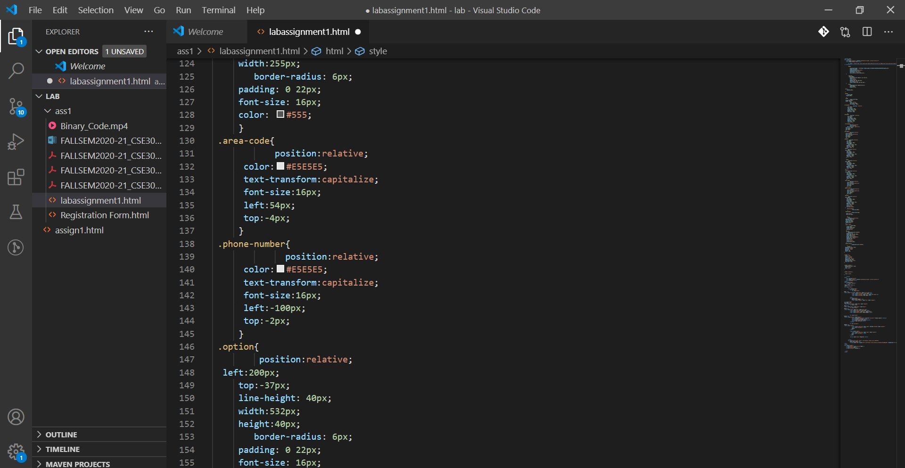

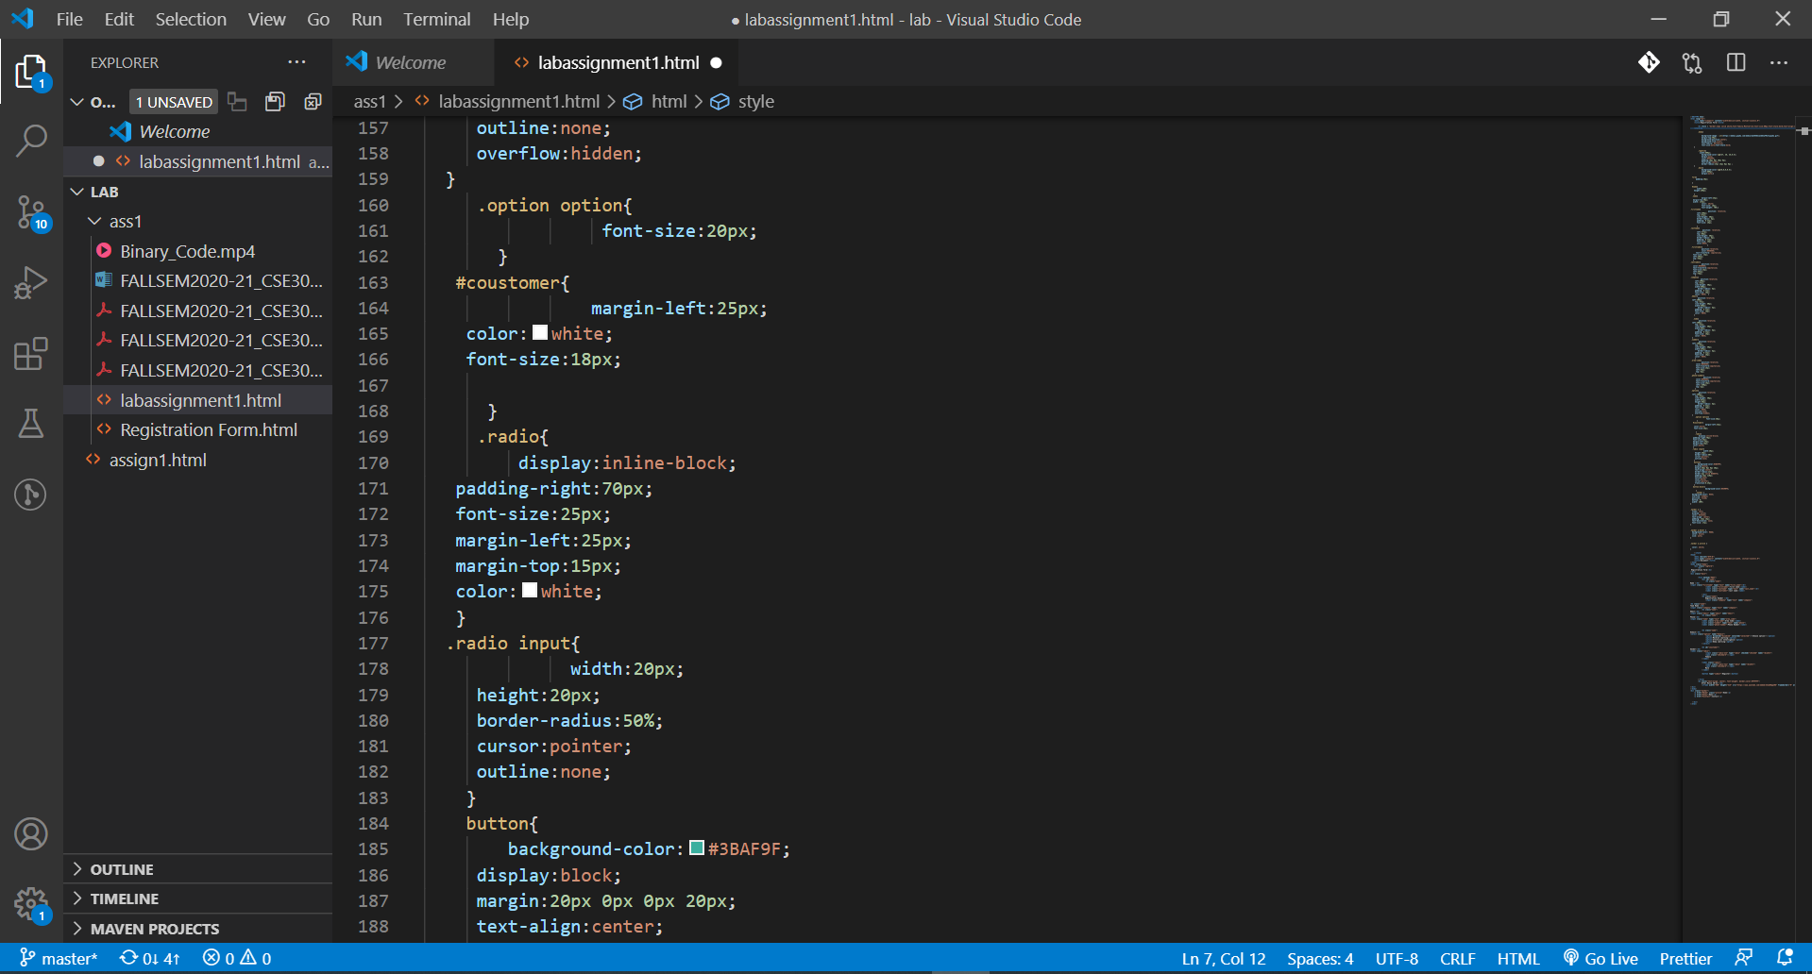

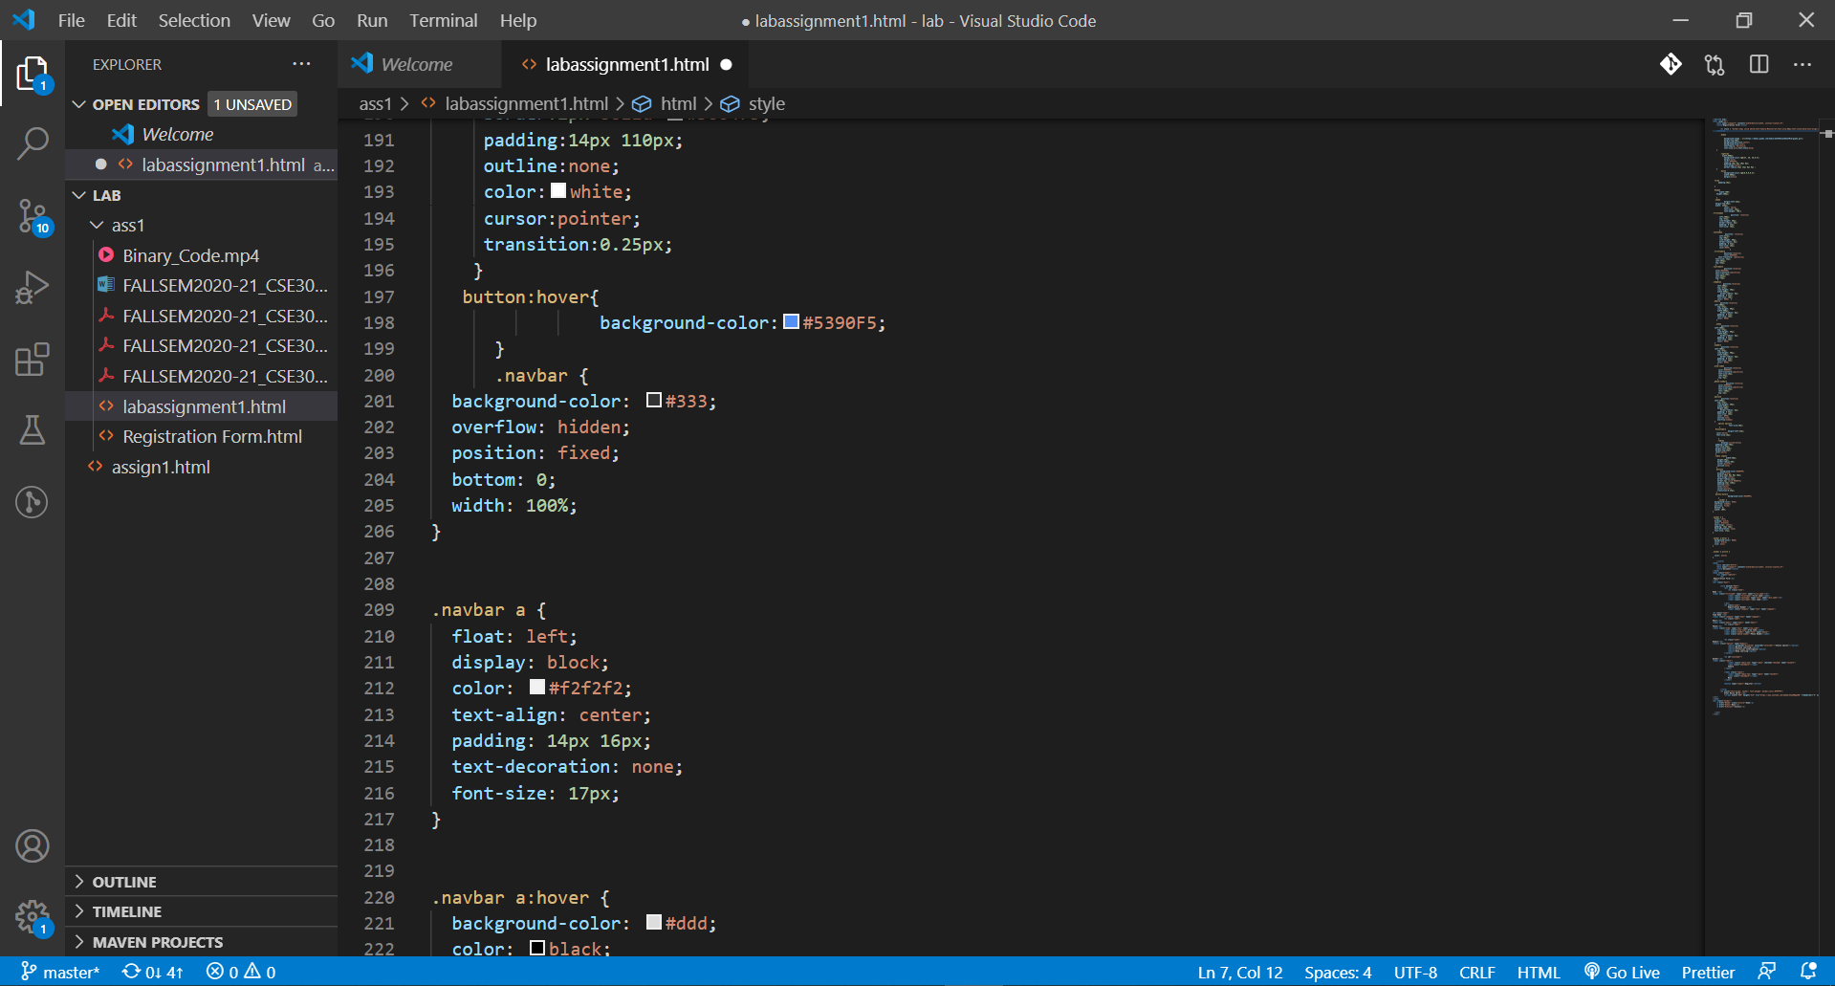

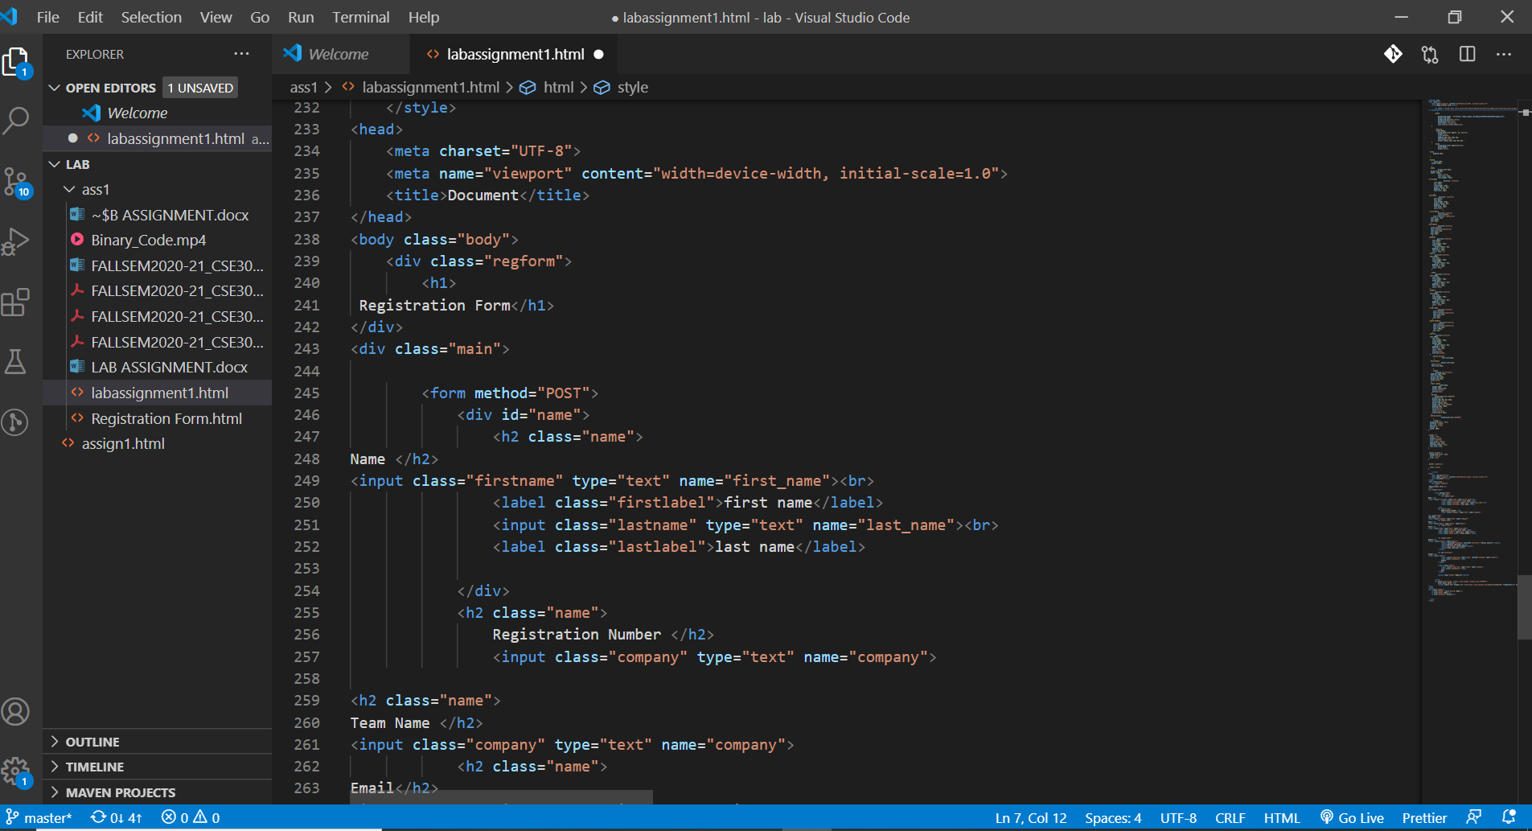

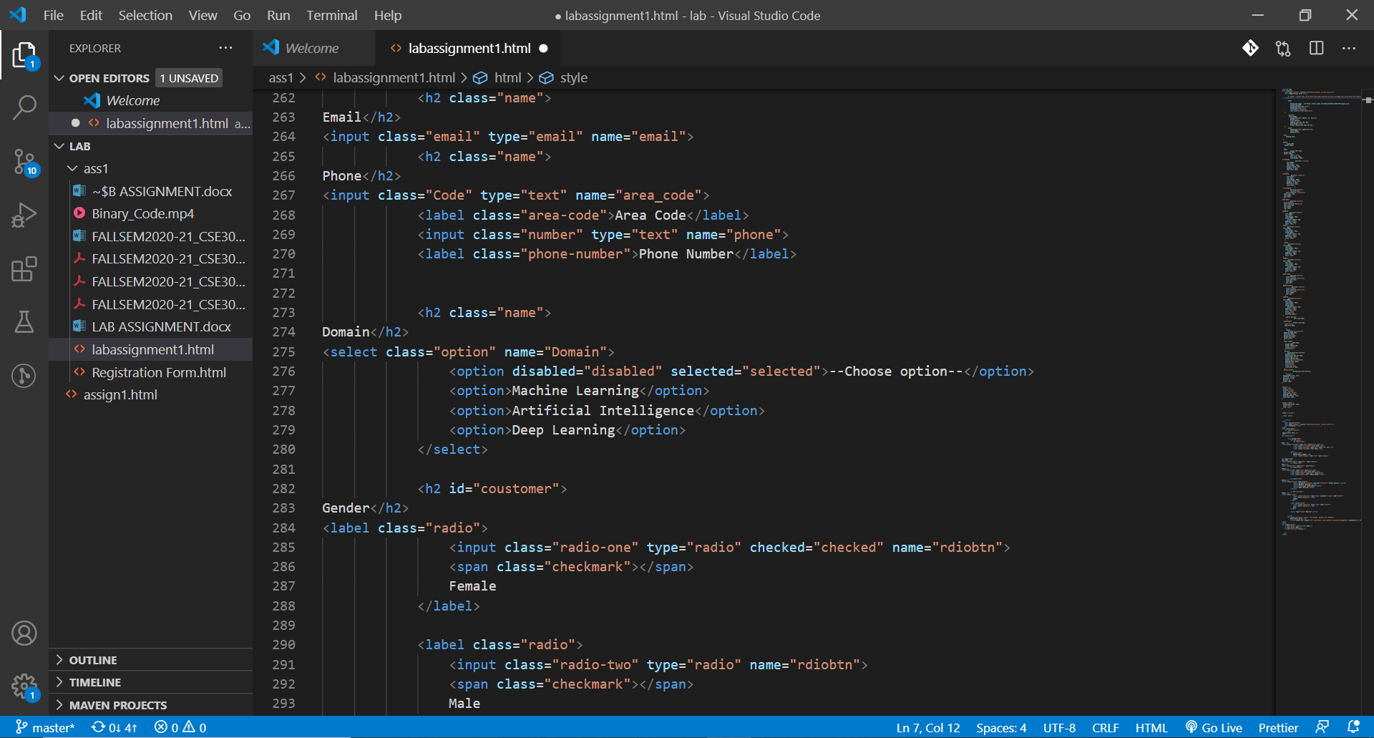

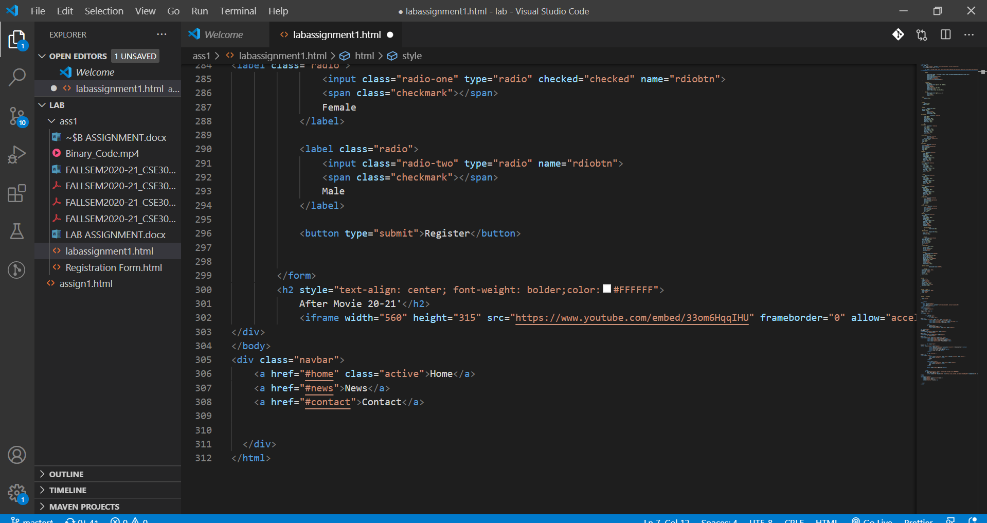

**HTML PAGE LOOKS:**



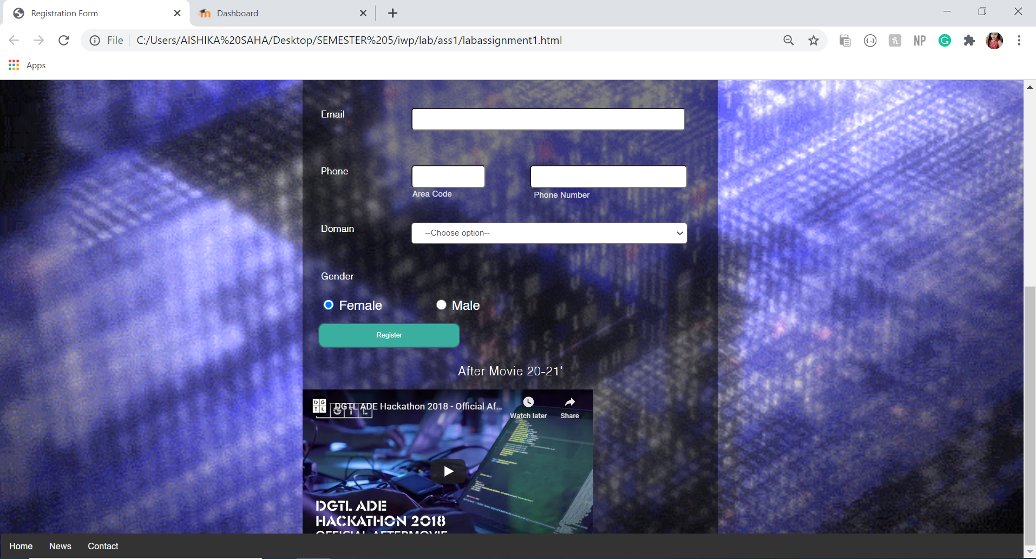

**CODE:**

<!DOCTYPE html>

<html lang="en">

    <meta name="viewport" content="width=device-width, initial-scale=1.0">

    <title>Registration Form</title>

        <h1 style = "border:12px solid white;font-family:Montserrat;font-size:80px;font-style:bold;text-align:center;"> <span style="color:#eceeee">The UltimateHACK.EXE</span></h1>

    <style>

        .body{

            background-image : url(https://media.giphy.com/media/du444G2zanbAnyYRcZ/giphy.gif);

            margin-top:40px;

            background-position:center;

            background-size:cover;

            font-family: Helvetica;

            font-size:auto;font-style:bold;

    }

        .regform{

          width:800px;

            background-color:rgb(37, 28, 28,0.5);

            margin:auto;

            color:#FFFFFF;

            padding:10px 0px 10px 0px;

            text-align:center;

            border-radius:15px 15px 0px 0px ;

    }

        .main{

            background-color:rgb(0,0,0,0.5);

            width:800px;

            margin:auto;}

  form{

      padding:10px;

  }

  #name{

       width:100%;

    height:100px;

    }

  .name{

            margin-left:25px;

   margin-top:30px;

   width: 125px;

            color: white;

            font-size: 18px;

            font-weight: 700;}

.firstname{

                   position: relative;

       left:200px;

       top:-37px;

       line-height: 40px;

       border-radius: 6px;

       padding: 0 22px;

       font-size: 16px;

       }

.lastname{

             position: relative;

       left:417px;

       top:-80px;

       line-height: 40px;

       border-radius: 6px;

       padding: 0 22px;

       font-size: 16px;

       color:#555;

                  }

 .firstlabel{

            position:relative;

            color:#E5E5E5;

      text-transform: capitalize;

   font-size: 14px;

   left:203px;

   top:-45px;

   }

.lastlabel{

            position:relative;

   color:#E5E5E5;

   text-transform:capitalize;

   font-size:14px;

   left:492px;

   top:-76px;

     }

.company{

           position:relative;

     left:200px;

     top:-37px;

     line-height: 40px;

     width:480px;

        border-radius: 6px;

     padding: 0 22px;

     font-size: 16px;

     color: #555;  }

 .email{

        position:relative;

  left:200px;

     top:-37px;

     line-height: 40px;

     width:480px;

        border-radius: 6px;

     padding: 0 22px;

     font-size: 16px;

     color: #555;

    }

   .Code{

         position:relative;

  left:200px;

     top:-37px;

     line-height: 40px;

     width:95px;

        border-radius: 6px;

     padding: 0 22px;

     font-size: 16px;

     color: #555;

  }

 .number{

         position:relative;

  left:200px;

     top:-37px;

     line-height: 40px;

     width:255px;

        border-radius: 6px;

     padding: 0 22px;

     font-size: 16px;

     color: #555;

     }

 .area-code{

            position:relative;

      color:#E5E5E5;

      text-transform:capitalize;

      font-size:16px;

      left:54px;

      top:-4px;

     }

 .phone-number{

              position:relative;

      color:#E5E5E5;

      text-transform:capitalize;

      font-size:16px;

      left:-100px;

      top:-2px;

     }

 .option{

         position:relative;

  left:200px;

     top:-37px;

     line-height: 40px;

     width:532px;

     height:40px;

        border-radius: 6px;

     padding: 0 22px;

     font-size: 16px;

     color: #555;

     outline:none;

     overflow:hidden;

  }

     .option option{

                 font-size:20px;

       }

   #coustomer{

                margin-left:25px;

    color:white;

    font-size:18px;

      }

     .radio{

         display:inline-block;

   padding-right:70px;

   font-size:25px;

   margin-left:25px;

   margin-top:15px;

   color:white;

   }

  .radio input{

              width:20px;

     height:20px;

     border-radius:50%;

     cursor:pointer;

     outline:none;

    }

    button{

        background-color:#3BAF9F;

     display:block;

     margin:20px 0px 0px 20px;

     text-align:center;

     border-radius:12px;

     border:2px solid #366473;

     padding:14px 110px;

     outline:none;

     color:white;

     cursor:pointer;

     transition:0.25px;

    }

   button:hover{

                background-color:#5390F5;

      }

      .navbar {

  background-color: #333;

  overflow: hidden;

  position: fixed;

  bottom: 0;

  width: 100%;

}

.navbar a {

  float: left;

  display: block;

  color: #f2f2f2;

  text-align: center;

  padding: 14px 16px;

  text-decoration: none;

  font-size: 17px;

}

.navbar a:hover {

  background-color: #ddd;

  color: black;

  size: auto;

}

.navbar a.active {

  color: white;

}

    </style>

<head>

    <meta charset="UTF-8">

    <meta name="viewport" content="width=device-width, initial-scale=1.0">

    <title>Document</title>

</head>

<body class="body">

    <div class="regform">

        <h1>

 Registration Form</h1>

</div>

<div class="main">

        <form method="POST">

            <div id="name">

                <h2 class="name">

Name </h2>

<input class="firstname" type="text" name="first_name"><br>

                <label class="firstlabel">first name</label>

                <input class="lastname" type="text" name="last_name"><br>

                <label class="lastlabel">last name</label>

            </div>

            <h2 class="name">

                Registration Number </h2>

                <input class="company" type="text" name="company">

<h2 class="name">

Team Name </h2>

<input class="company" type="text" name="company">

            <h2 class="name">

Email</h2>

<input class="email" type="email" name="email">

            <h2 class="name">

Phone</h2>

<input class="Code" type="text" name="area_code">

            <label class="area-code">Area Code</label>

            <input class="number" type="text" name="phone">

            <label class="phone-number">Phone Number</label>

            <h2 class="name">

Domain</h2>

<select class="option" name="Domain">

                <option disabled="disabled" selected="selected">--Choose option--</option>

                <option>Machine Learning</option>

                <option>Artificial Intelligence</option>

                <option>Deep Learning</option>

            </select>

            <h2 id="coustomer">

Gender</h2>

<label class="radio">

                <input class="radio-one" type="radio" checked="checked" name="rdiobtn">

                <span class="checkmark"></span>

                Female

            </label>

            <label class="radio">

                <input class="radio-two" type="radio" name="rdiobtn">

                <span class="checkmark"></span>

                Male

            </label>

            <button type="submit">Register</button>

        </form>

        <h2 style="text-align: center; font-weight: bolder;color:#FFFFFF">

            After Movie 20-21'</h2>

            <iframe width="560" height="315" src="https://www.youtube.com/embed/33om6HqqIHU" frameborder="0" allow="accelerometer; autoplay; encrypted-media; gyroscope; picture-in-picture" allowfullscreen></iframe>

</div>

</body>

<div class="navbar">

    <a href="#home" class="active">Home</a>

    <a href="#news">News</a>

    <a href="#contact">Contact</a>

  </div>

</html>